INTRODUCTION TO PROGRAMMING (COIT20245)

Term 2, 2019
Assessment 1:
Student ID | 12116421
Student Name | Bishal Budhathoki
Campus | Sydney (On-Campus)
Tutor | Aries Tao

Output:
Here, N = 6
- This output is obtained from the sample output given from the question.
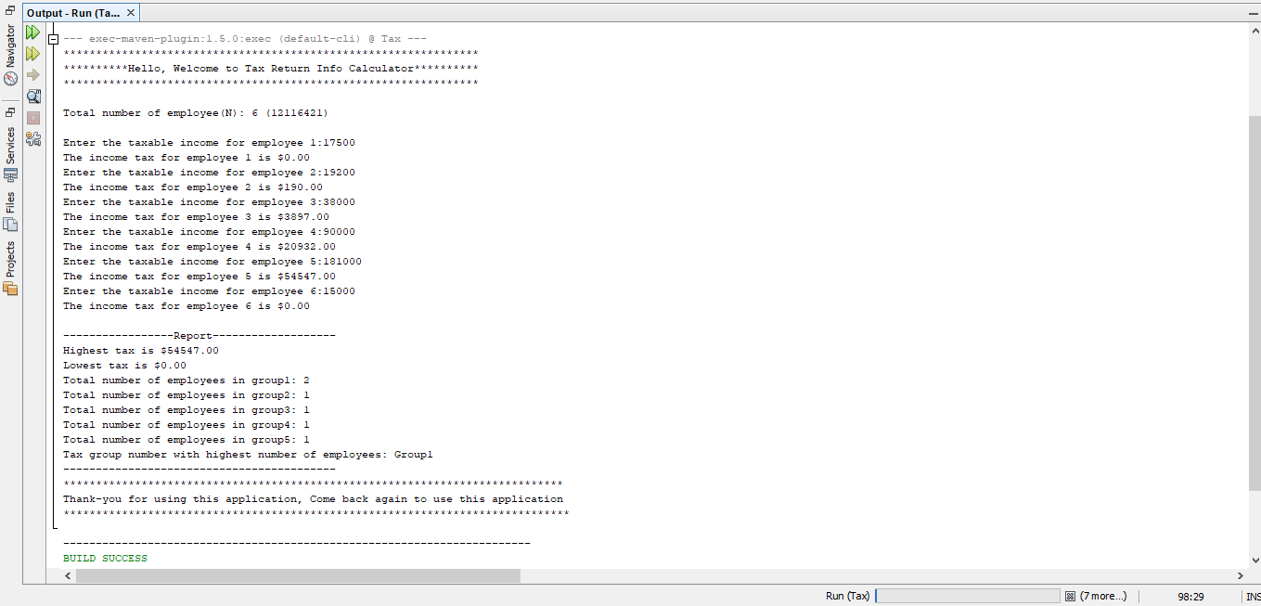
b) Here negative value is introduced for 6th employee and a message are displayed saying salary cannot be in negative. Also, here group 1 and group 5 have equal number of employees 2, so highest group number which is 5 is displayed.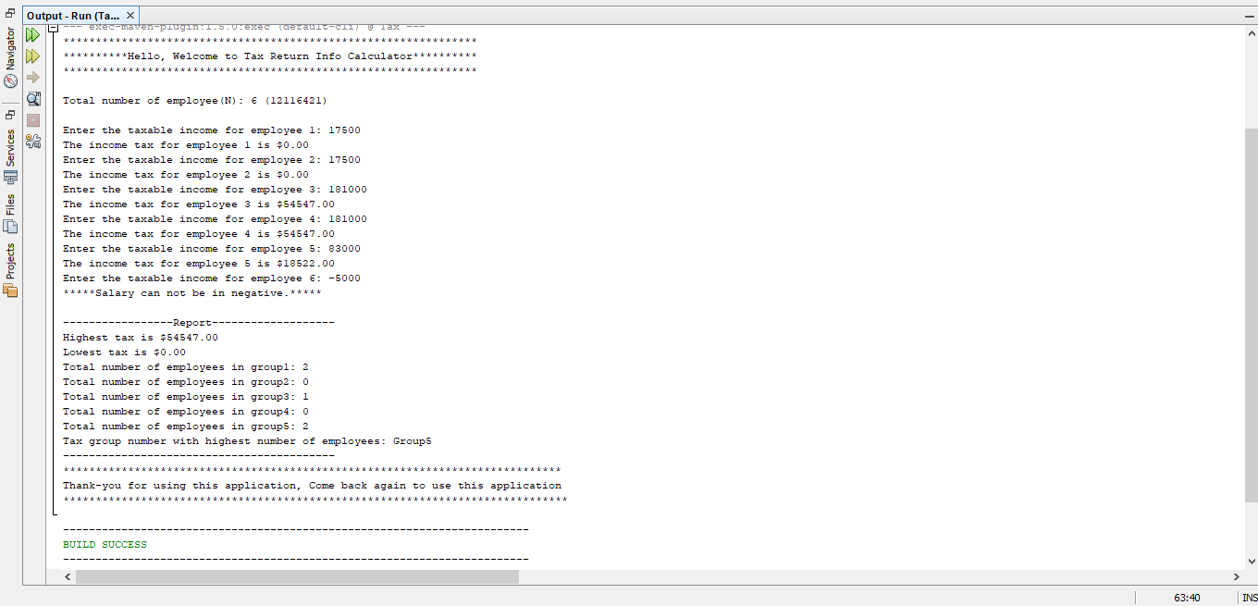
c) Here input is given alphabet not numeric value leading to an error.
